**Lab 14: (A) How to put media files on HTML page**

**Code:**

 <!DOCTYPE html>

<html lang="en">

<head>

    <meta charset="UTF-8">

    <meta name="viewport" content="width=device-width, initial-scale=1.0">

    <title>Document</title>

</head>

<body style="background-image: url('img_girl.jpg');" link="blue" alink="green" vlink="#FF0000" >

<h2>Video</h2>

    <video width="320" height="120" controls style="float:left;margin-bottom:200px;">

        <source src="../Images/Motivational.mp4" type="video/ogg">

      </video>

      <br>  <br>  <br> <br> <br><br> <br>

<h2>Audio</h2>

<audio controls autoplay>

        <!-- <source src="audio.ogg" type="audio/ogg"> -->

        <source src="bird.mp3" type="audio/mpeg">

</audio>

<iframe frameborder="0" width="500" height="320" src="https://www.youtube.com/embed/mzPxo7Y6JyA">

</iframe>

</body>

</html>

**OUTPUT:**

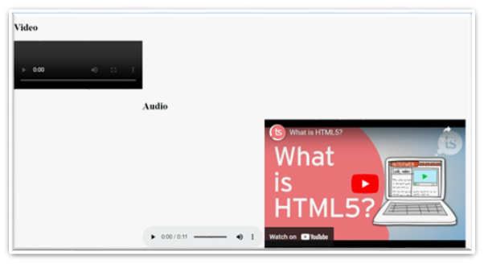

**Lab 14: (B) How to create graphics**  **on HTML page**

**Lab 14(B)-(i): SVG**

**Code:**

 <!DOCTYPE html>

<html>

<body>

<svg width="500" height="500">

  <rect width="500" height="500" style="fill:rgb(100,200,255);stroke-width:3;stroke:rgb(0,0,0)" />

  <circle cx="50" cy="50" r="40" stroke="blue" stroke-width="3" fill="cyan" />

  Sorry, your browser does not support inline SVG.

  <ellipse cx="200" cy="80" rx="100" ry="50"

  style="fill:yellow;stroke:purple;stroke-width:2" />

  <line x1="0" y1="0" x2="200" y2="400" style="stroke:rgb(255,100,0);stroke-width:2" />

   <polygon points="400,10 250,190 160,210" style="fill:lime;stroke:purple;stroke-width:1" />

   <polyline points="20,20 40,25 60,40 80,120 120,140 400,180"

  style="fill:none;stroke:black;stroke-width:3" />

  <text x="0" y="15" fill="hotpink">GRAPHICS!!</text>

</svg>

</body>

</html>

OUTPUT:

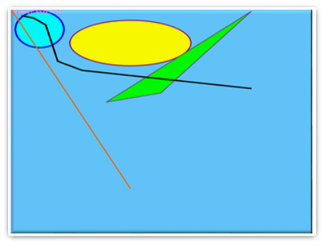

**Lab 14(B)-(ii): CANVAS**

**Code:**

<!DOCTYPE html>

<html>

<body>

<canvas id="myCanvas" width="200" height="100" style="border:1px solid #000000;">

Your browser does not support the HTML canvas tag.

</canvas>

<canvas id="myCanvas" width="200" height="100" style="border:1px solid #d3d3d3;">

Your browser does not support the HTML canvas tag.</canvas>

<script>

var c = document.getElementById("myCanvas");

var ctx = c.getContext("2d");

ctx.moveTo(0,0);

ctx.lineTo(200,100);

ctx.stroke();

</script>

</body>

</html>

**OUTPUT:**

